**SQL COMMANDS ASSIGNMENT -1**

**1.**show all employeees who work in IT department

Query : select * from employeees where department = 'IT';

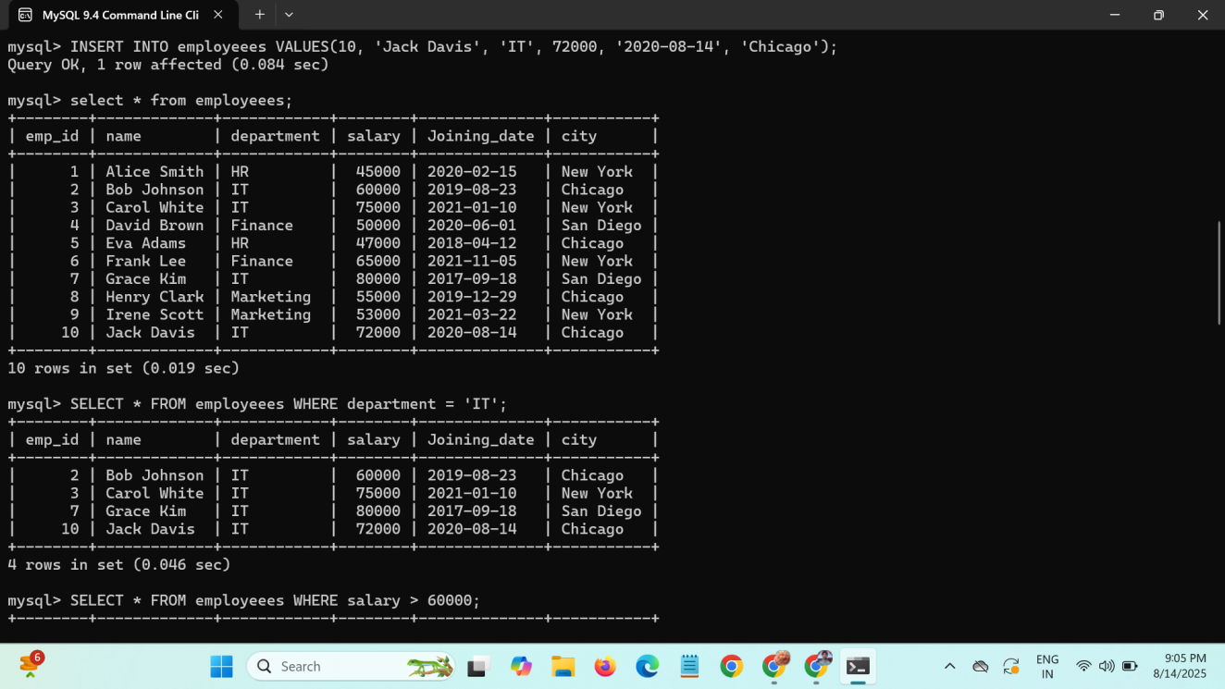

**2.**Find employeees whose salary greater than 60,000.

Query : select * from employeees where salary > 60000;

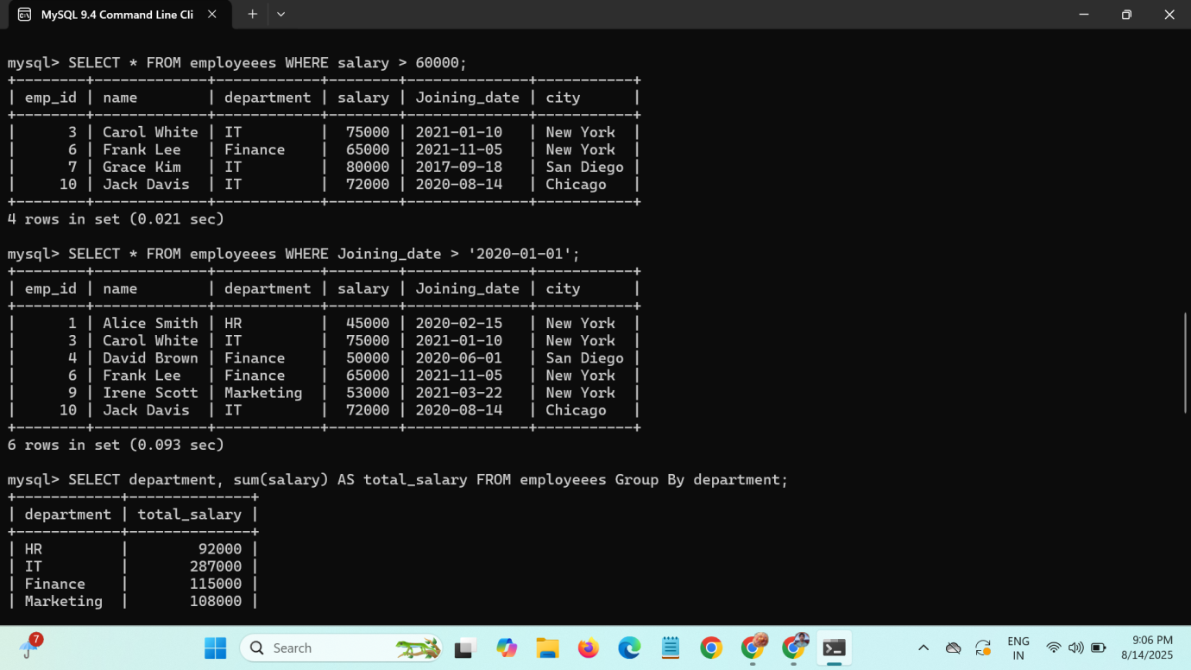

**3.**Get all employeees who joined after 1st jan 2020.

Query : select * from employeees where joining_date > '2020-01-01';



**4.**Find the total salary paid to employees in each department.

Query : select department, sum(salary) as total_salary from employeees GROUP BY department;

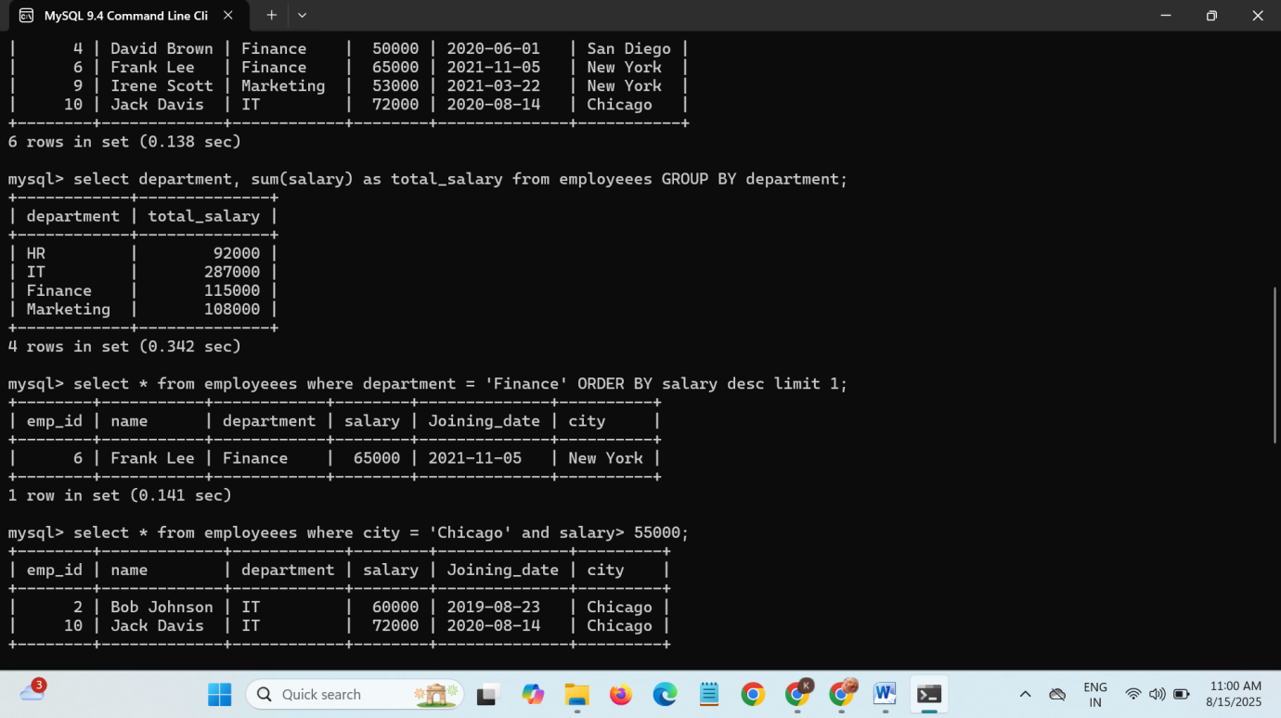

**5.**show the highest paid employee in finance department.

Query : select * from employeees where department = 'Finance' ORDER BY salary desc limit 1;

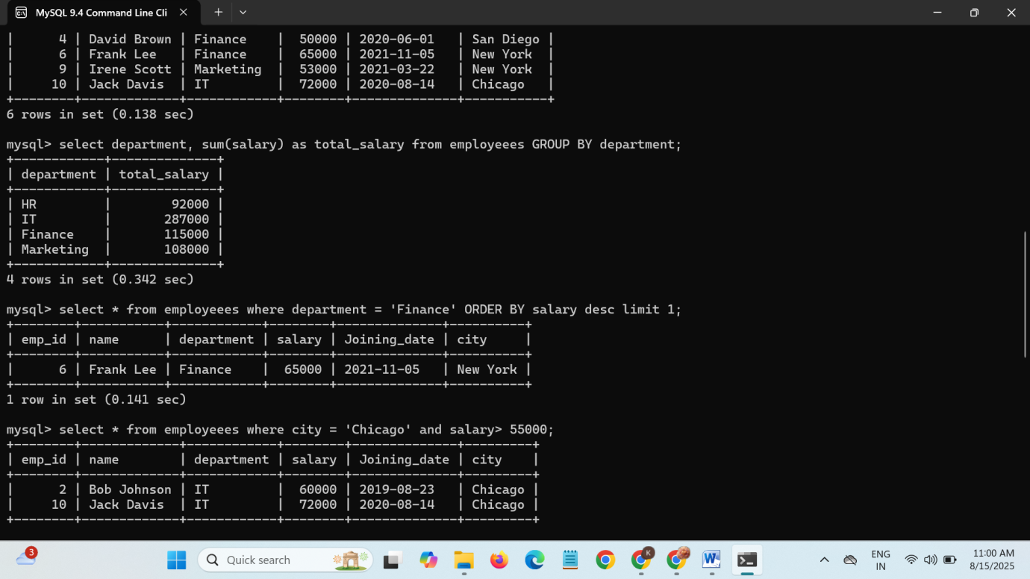

**6.**list employees who are from Chicago and earn more than 55000.

Query : select * from employeees where city = 'Chicago' and salary > 55000;

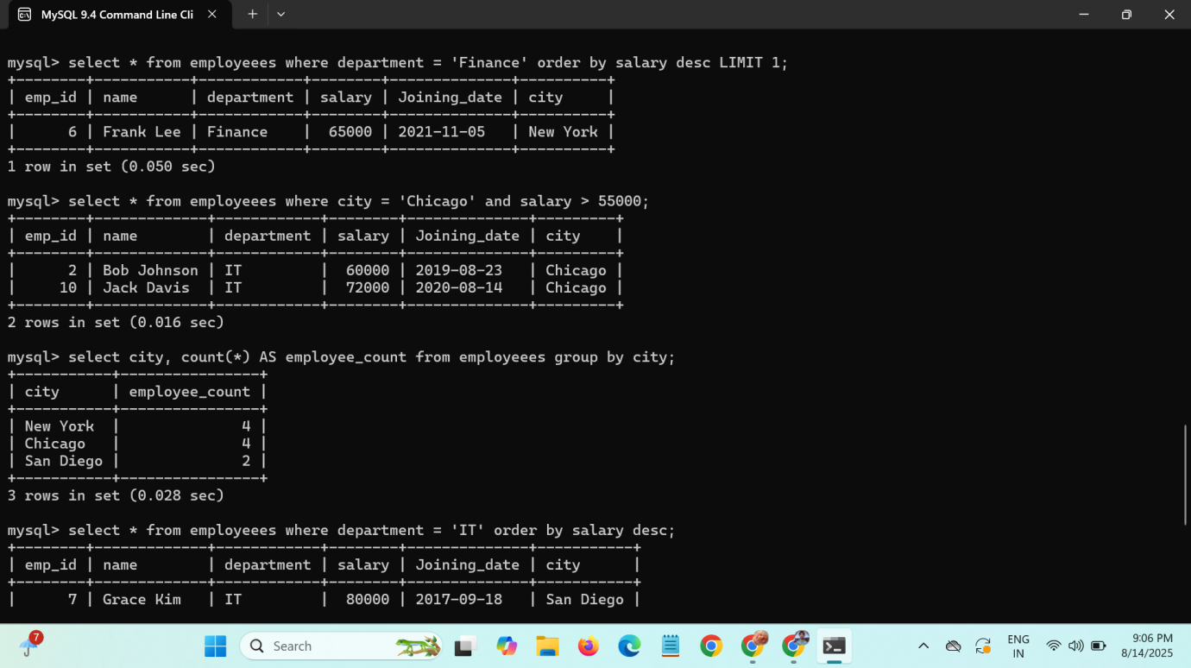

**7.**Find the number of employees in each city.

Query : select city, count(*) as employee_count from employeees GROUP BY city;

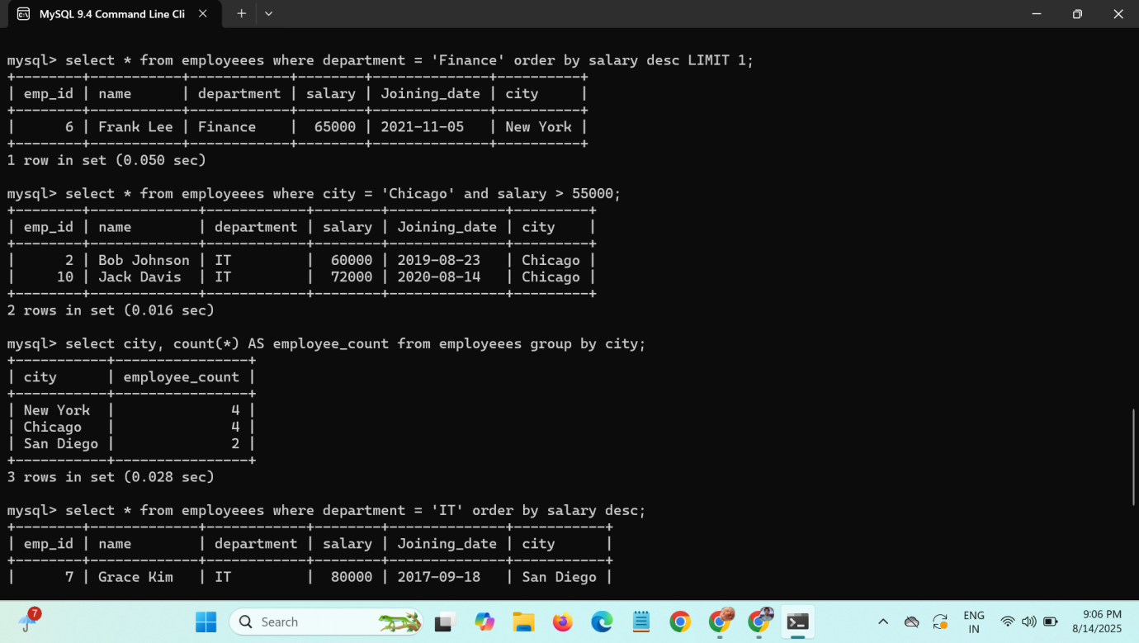

**8.**show employees in IT department ordered by salary in descending order.

Query : select * from employeees where department = 'IT' ORDER BY salary desc;

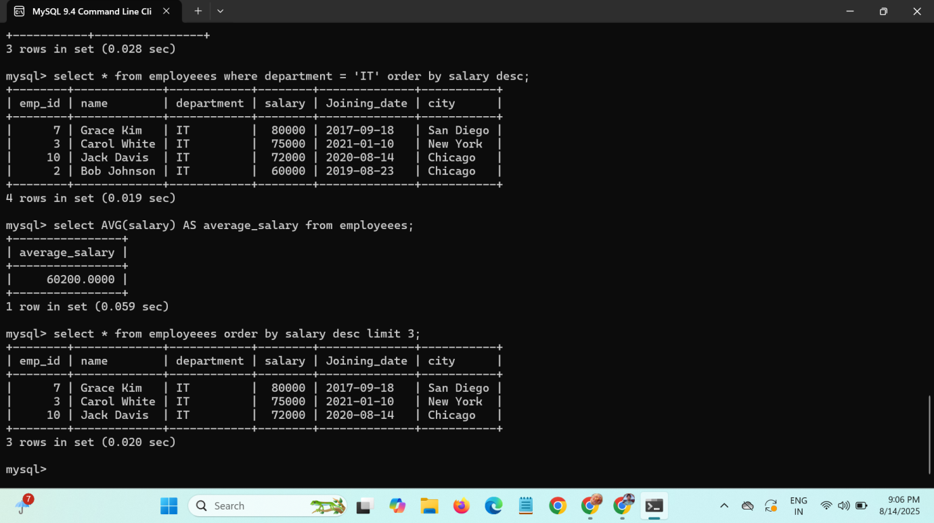

**9.**Display average salary of all employeees.

Query : select avg(salary) from employeees;



**10.** Get the details of the top 3 highest paid employeees.

Query : select * from employeees ORDER BY salary desc limit 3;

